Version 16. October 2015

Preliminary Agenda
3rd EU BON Stakeholder Roundtable
10th – 11th December 2015, Granada, Spain

- Rationale:
The next EU BON Roundtable “Workflow from data mobilisation to practice” will be held at the 10th/11th December 2015 in Granada, Spain and hosted by our EU BON partners from the University of Granada. The roundtable will focus on EU BON test sites to discuss data mobilisation at the site level, workflows of data/information and the further usage for policy reporting and political processes, e.g. CBD and IPBES. Current state, gaps and barriers as well as best practice examples will be discussed with partners from EU BON and related European biodiversity projects. Furthermore local stakeholders of the test site will take part in the discussions.
- Basic Information:

- Format: 2-days workshop, lunch to lunch meeting, excursion (11 th Dec. afternoon, Sierra Nevada Mountains)
- Venue: 1st day: Carmen de la Victoria. Cuesta del Chapiz, 9. 18010 Granada, Spain
2nd day : La Cortijuela (Sierra Nevada mountains)
- Local Host: Dr. Francisco Bonet and Prof. Regino Zamora, University of Granada: Granada / Sierra Nevada, Spain.

- Aims of the Roundtable:
- Data mobilisation: Mapping existing workflows of data/information and current barriers that prevent effective reporting, finding solutions to improve current workflows of biodiversity data and the potential for (EU BON) tools, protocols and standards using test site cases and stakeholders.
- Outlining current limitations and gaps with regard to the biodiversity data workflows.
- Identifing the benefits for stakeholders by participating in the EU BON project (e.g. tools and services).

Preliminary Agenda

This is just a first overview of the scheduled sessions - we will approach you for your contributions / talks.

Thursday, 10th December - Carmen de la Victoria :
Workflow from data mobilisation to practice – best practice examples and stakeholder needs

9:00 – 11:00 Free meeting slots

12:30 Arrival – Registration – small Lunch (Sandwiches)
14:00 Welcome & Introduction
14:30 Experience in data mobilization, processing and modelling from the test sites (10 minutes)
• WP 5 (N.N.)

14:45 Current State of the Biodiversity Portal - Interactive Session
15:00 Tools and Products for biodiversity data workflows (5 min. each, max. 3 slides/participant)
15:30 Coffee Break
16:00 Stakeholder Demands: Data, tools, products and current workflows
18:00 Wrap up of day 1
18:30 End of day 1

Friday, 11th December: La Cortijuela (Sierra Nevada mountains):
Test sites, improvement of data workflows and stakeholder feed back

7:30 Travel to Venue in the Sierra Nevada mountains (La Cortijuela)
9:30 World Cafés and Working Groups (1.5 h, participants will move between groups) – Test Sites, workflows and current gaps
- Test Site Stakeholder
- Test Site Issues
- EU BON Portal and Test Site Portals
- Models and Tools
- Data Flow and barriers (tba), e.g. REDIAM experiences and link to networks & BONs
11:00 Presentation of the World Café Results and Discussion (30 min)
11:30 General Discussion and mapping of Stakeholder Requirements (existing vs. wish list)
12:00 Closing Remarks
- Feedback of the workshop from a test site perspective (Francisco Bonet / Regino Zamora)
- Feedback of the workshop from a EU BON perspective (Christoph Häuser)
12:15 End of the roundtable (departure of participants that do not stay for the excursion)
12:30 Lunch – Paella Cooking at the field station (1.5 hour)
14:30 Excursion
- Visit of the botanic garden (0.5 hour)
- Visit good adaptive management practices at the test site (1 hour)
17:00 Travel back to Granada

Accommodation

- Carmen de la Victoria. Cuesta del Chapiz, 9. 18010 – Granada
- Guesthouse (limited availability): Corrala de Santiago. http://corraladesantiago.ugr.es/. 20' walking to the venue (https://goo.gl/A1yCJk)

For reservations at the Guesthouse „Carmen de la Victoria“ or "Corrala de Santiago" please contact Pepa Rodríguez (peparodriguezinfante@gmail.com ).

Location Guesthouse (Carmen): http://goo.gl/q7xBvf

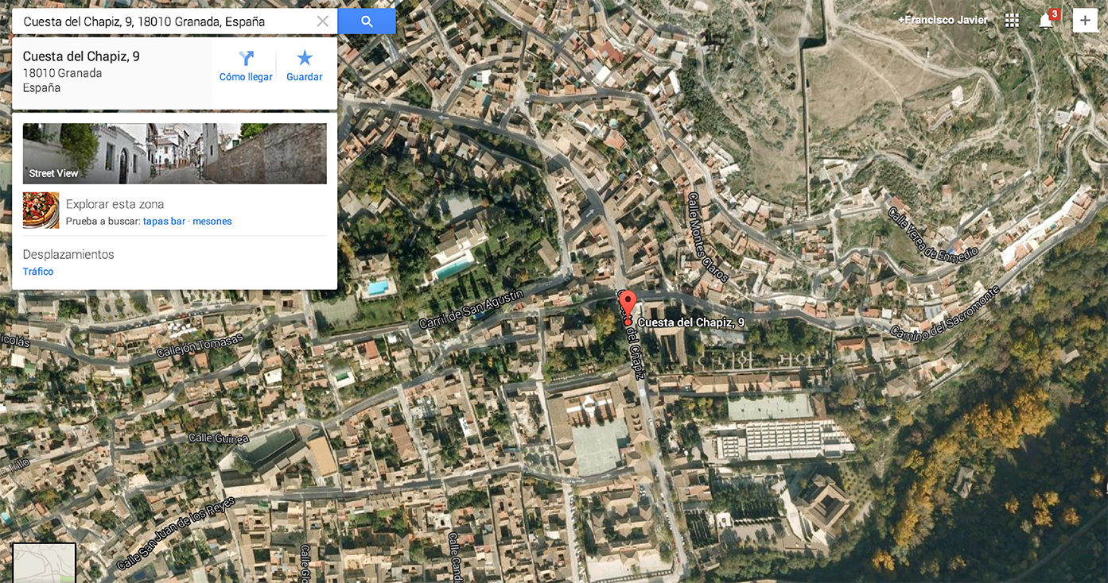
´
´
Travel:

Proposed travel (plane/train). There is the possibility to fly to Granada Airport. Another possibility is to take the plane to Málaga and take the bus from this airport to Granada city.

Second day of the meeting will be held in the mountains, please consider to bring warm clothing for a stay in the mountains with you.

Contact:
Dr. Francisco Bonet
Universidad de Granada
email: fjbonet@ugr.es

For room reservations please contact: Pepa Rodríguez peparodriguezinfante@gmail.com

Further contacts:
Dr. Katrin Vohland (Katrin.vohland@mfn-berlin.de)
Dr. Florian Wetzel (florian.wetzel@mfn-berlin.de)

